.

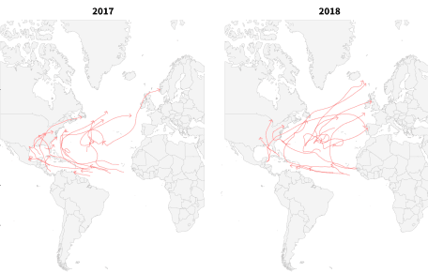

Earlier this year, A simple R package (available at [basilesimon/noaastorms](https://github.com/basilesimon/noaastorms)) that downloads, cleans and parses NOAA IBtrack data for you.

As the NOAA updated its datasets, noaastorms is now using these!

**How to install**

library(devtools)

install_github("basilesimon/noaastorms")

**Available functions**

getStorms: Fetch NOAA historical best track storms data

> df <- getStorms(c('EP'))

> head(df[1:5])

Serial_Num Season Num Basin Sub_basin Name

2 1902276N14266 1902 01 EP MM UNNAMED

3 1902276N14266 1902 01 EP MM UNNAMED

4 1902276N14266 1902 01 EP MM UNNAMED

5 1902276N14266 1902 01 EP MM UNNAMED

6 1902276N14266 1902 01 EP MM UNNAMED

The first argument is a vector of basin codes from this list:

* NA: North Atlantic
* SA: South Atlantic
* NI: North Indian
* SI: South Indian
* EP: East Pacific
* SP: South Pacific
* WP: West Pacific

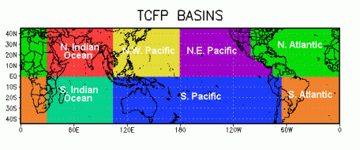

To get storms that took place in the Atlantic for example, run getStorms(c('NA', 'SA')).

The second (optional) argument is a date range to filter data with. For example:

dateRange <- c(as.Date('2010-01-01'), as.Date('2012-12-31'))

getStorms(c('NA', 'SA'), dateRange = dateRange)

Will query storms that took place in the Atlantic in 2010 and 2012.

**Usage**

# load a map of the world and

# use `clipPolys` to avoid issues

# when zooming in with `coord_map`

wm <- map_data("world")

library("PBSmapping")

data.table::setnames(wm, c("X","Y","PID","POS","region","subregion"))

worldmap <- clipPolys(wm,

xlim=c(20,110),ylim=c(0, 45),

keepExtra=TRUE)

# load storms for the Atlantic ocean

spStorms <- getStorms(c('NA', 'SA'))

ggplot(spStorms,

aes(x = Longitude, y = Latitude,

group = Serial_Num)) +

geom_polygon(data = worldmap,

aes(x = X, y = Y, group = PID),

fill = "whitesmoke",

colour = "gray10",

size = 0.2) +

geom_path(alpha = 0.1, size = 0.8,

color = "red") +

coord_map(xlim = c(20,110),

ylim = c(0, 45))

